13.66: a)
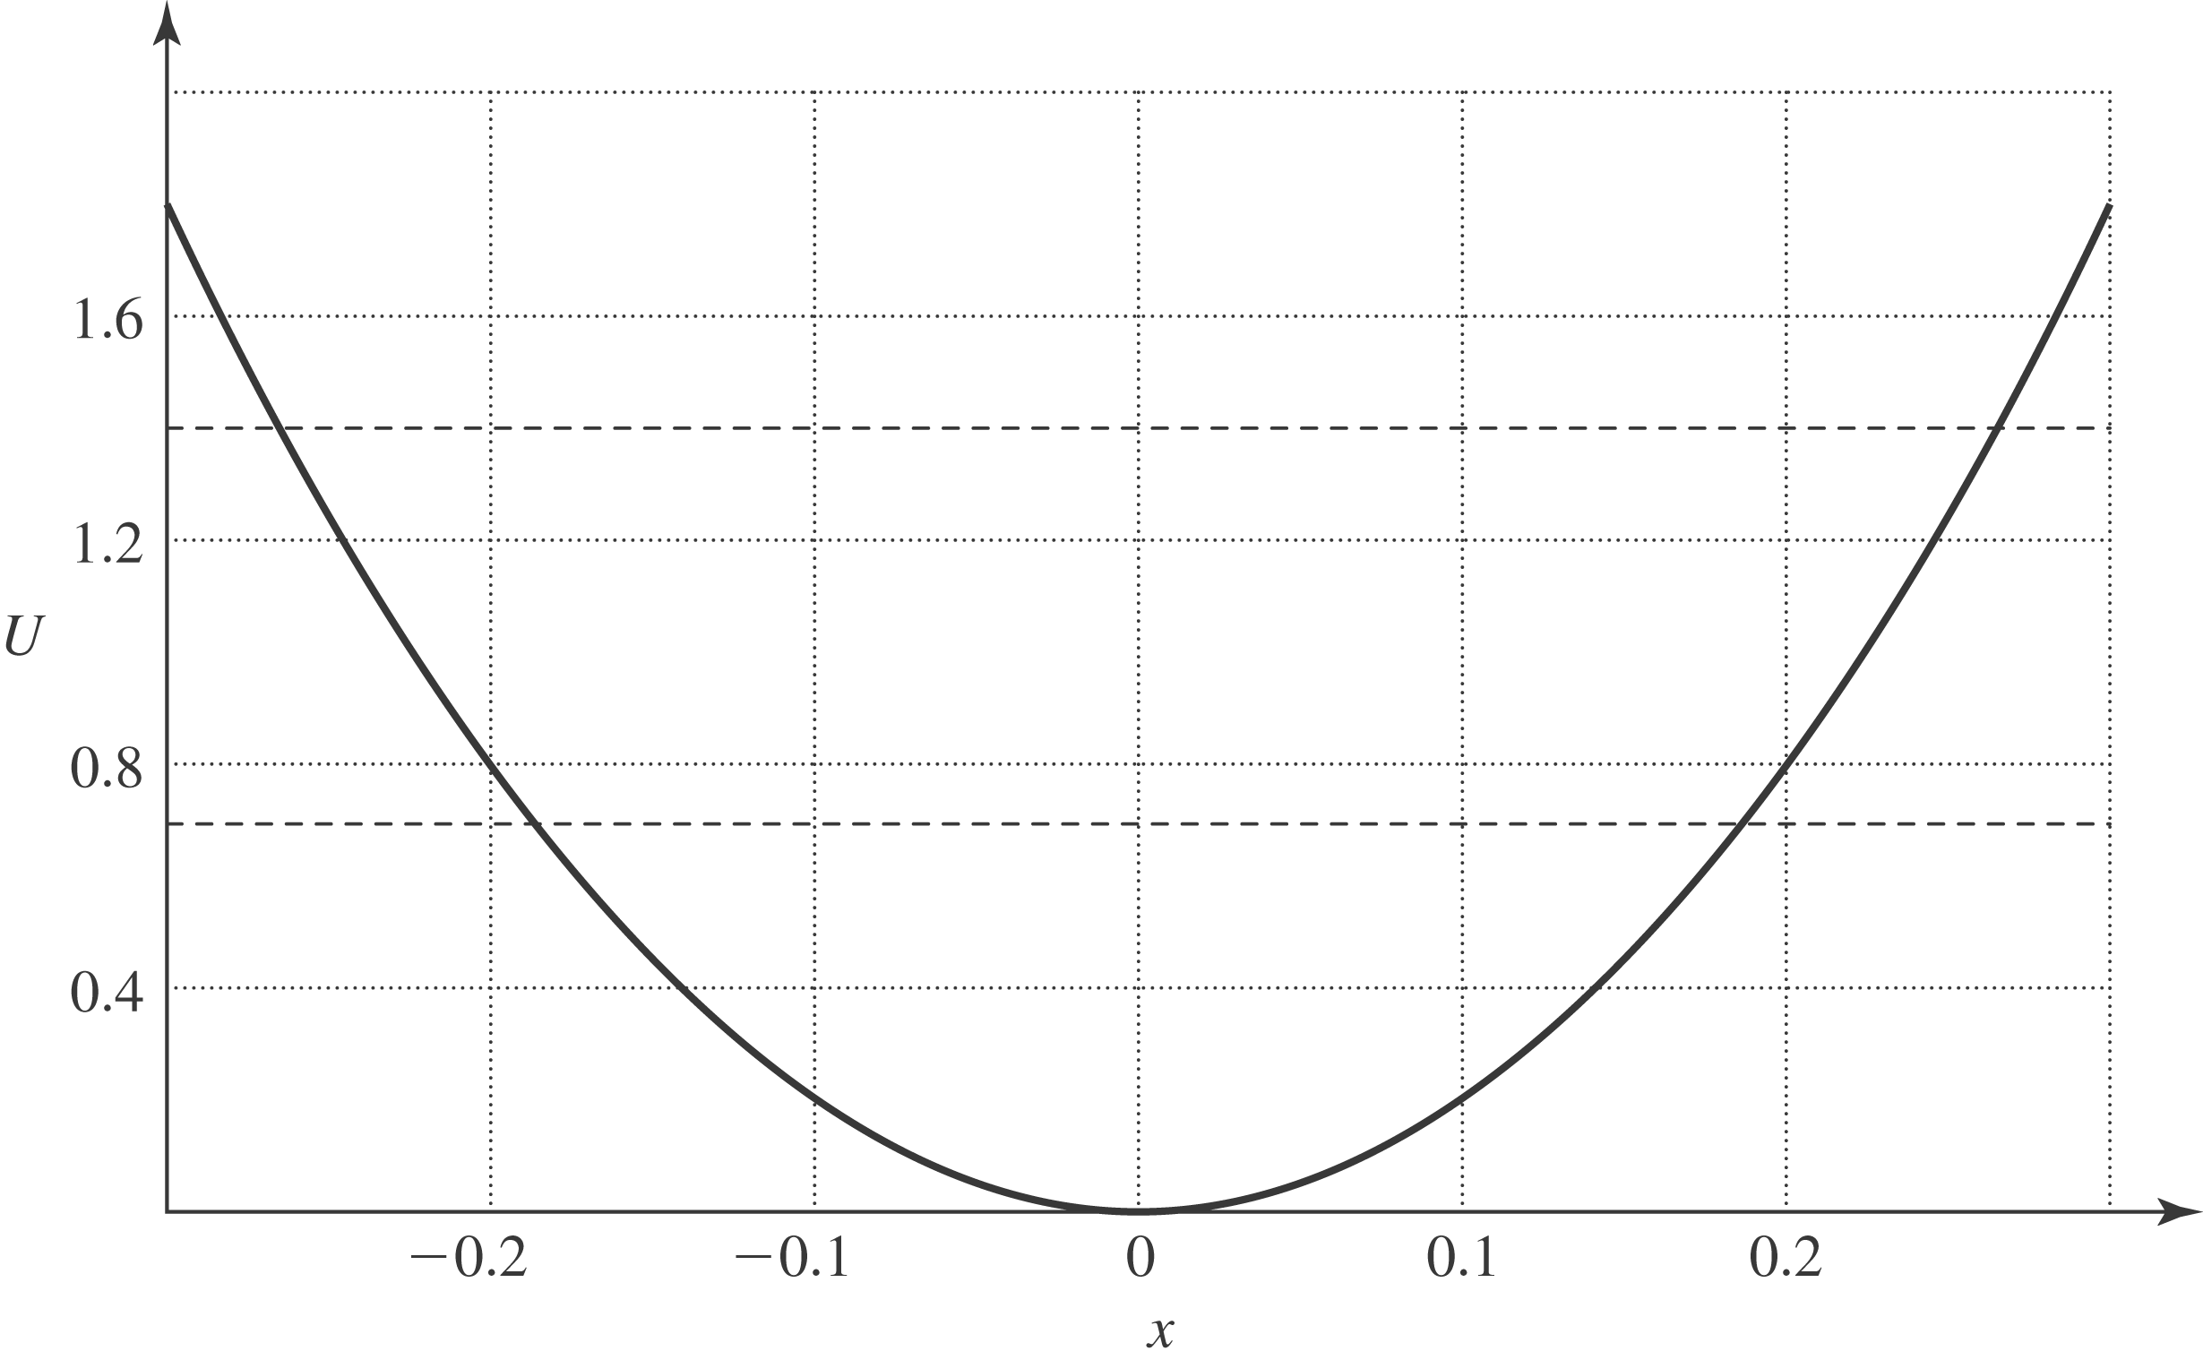

For space considerations, this figure is not precisely to the scale suggested in the problem. The following answers are found algebraically, to be used as a check on the graphical method.
b) 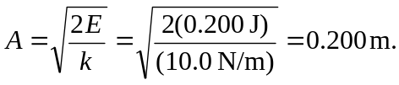
c) e) From Eq. (13.18), using
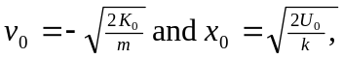
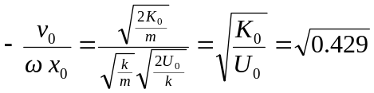
and 

